**Assignment 5 TD3**

**Task 1: Environment Setup (Dynamic Goals and Constraints)**

class DynamicEnvironment:

    def __init__(self, size=(10, 10), max_velocity=1.0, goal_update_interval=20):

        self.size = size

        self.max_velocity = max_velocity

        self.goal_update_interval = goal_update_interval

        self.step_count = 0

        self.fig, self.ax = plt.subplots(figsize=(6, 6))

        plt.ion()

        self.reset()

    def reset(self):

        """Resets the environment to its initial state."""

        self.agent_position = np.array([np.random.uniform(0, self.size[0]), np.random.uniform(0, self.size[1])])

        self.goal_position = self._generate_new_goal()

        self.step_count = 0

        return self.agent_position, self.goal_position

    def _generate_new_goal(self):

        """Generates a new random goal position within the environment boundaries."""

        return np.array([np.random.uniform(0, self.size[0]), np.random.uniform(0, self.size[1])])

    def step(self, action):

        """Takes an action to update the environment state.

        Args:

            action (np.array): A 2D action vector representing velocity (dx, dy).

        Returns:

            tuple: (agent_position, goal_position, reward, done)

        """

        reward = -1  # Step penalty to discourage inefficiency

        # Check for exceeding maximum velocity

        if np.any(np.abs(action) > self.max_velocity):

            reward -= 10  # Penalty for exceeding velocity constraint

            action = np.clip(action, -self.max_velocity, self.max_velocity)

        # Apply velocity constraints and update agent position

        self.agent_position += action

        # Check for boundary violations

        if np.any(self.agent_position < 0) or np.any(self.agent_position > self.size):

            reward -= 5  # Penalty for moving out of bounds

            self.agent_position = np.clip(self.agent_position, 0, [self.size[0], self.size[1]])

        # Check for goal update

        self.step_count += 1

        if self.step_count % self.goal_update_interval == 0:

            self.goal_position = self._generate_new_goal()

        # Compute reward for proximity to goal

        distance_to_goal = np.linalg.norm(self.agent_position - self.goal_position)

        if distance_to_goal < 0.5:

            reward += 10  # Reward for reaching the goal

            done = True

        else:

            done = False

        return self.agent_position, self.goal_position, reward, done

    def render(self):

        """Renders the current state of the environment as a dynamic frame."""

        self.ax.clear()  # Clear the axes to update the frame

        self.ax.set_xlim(0, self.size[0])

        self.ax.set_ylim(0, self.size[1])

        self.ax.plot(self.agent_position[0], self.agent_position[1], 'bo', label='Agent')

        self.ax.plot(self.goal_position[0], self.goal_position[1], 'ro', label='Goal')

        self.ax.legend()

        self.ax.set_title("Environment State")

        plt.pause(0.1)

    def close(self):

        """Closes the rendering window."""

        plt.ioff()  # Turn off interactive mode

        plt.show()

**Task 2: TD3 Algorithm Implementation**

class ReplayBuffer:

    def __init__(self, max_size, input_shape, n_actions):

        """

        Initialize the replay buffer.

        Args:

        - max_size (int): Maximum number of transitions the buffer can store.

        - input_shape (tuple): Shape of the state space (e.g., (state_dim,)).

        - n_actions (int): Number of actions in the action space.

        Attributes:

        - max_size: Maximum buffer size.

        - mem_cntr: Counter to keep track of the number of transitions added.

        - state_memory: Array to store states.

        - new_state_memory: Array to store the next states.

        - action_memory: Array to store actions taken.

        - reward_memory: Array to store rewards received.

        - terminal_memory: Array to store terminal flags (whether the episode ended).

        """

        self.max_size = max_size

        self.mem_cntr = 0  # Initialize the memory counter to 0

        # Initialize memory arrays

        self.state_memory = np.zeros((self.max_size, input_shape))  # Stores states

        self.new_state_memory = np.zeros((self.max_size, input_shape))  # Stores next states

        self.action_memory = np.zeros((self.max_size, n_actions))  # Stores actions

        self.reward_memory = np.zeros(self.max_size)  # Stores rewards

        self.terminal_memory = np.zeros(self.max_size, dtype=np.float32)  # Stores done flags (1 - done)

    def store_transition(self, state, action, reward, state_, done):

        """

        Store a single transition in the replay buffer.

        Args:

        - state (array): Current state.

        - action (array): Action taken in the current state.

        - reward (float): Reward received after taking the action.

        - state_ (array): Next state after taking the action.

        - done (bool): Whether the episode ended after this transition.

        """

        # Find the index to store the transition (overwrites oldest transitions if full)

        index = self.mem_cntr % self.max_size

        # Store the transition components in their respective buffers

        self.state_memory[index] = state

        self.new_state_memory[index] = state_

        self.action_memory[index] = action

        self.reward_memory[index] = reward

        self.terminal_memory[index] = 1 - done  # Store 1 if not done, 0 if done

        # Increment the memory counter

        self.mem_cntr += 1

    def sample_buffer(self, batch_size):

        """

        Sample a batch of transitions from the replay buffer.

        Args:

        - batch_size (int): Number of transitions to sample.

        Returns:

        - states (array): Batch of sampled states.

        - actions (array): Batch of sampled actions.

        - rewards (array): Batch of sampled rewards.

        - states_ (array): Batch of sampled next states.

        - dones (array): Batch of sampled terminal flags (1 - done).

        """

        # Determine the maximum number of stored transitions

        max_mem = min(self.mem_cntr, self.max_size)

        # Randomly sample `batch_size` indices from the range [0, max_mem)

        batch = np.random.choice(max_mem, batch_size, replace=False)

        # Retrieve the sampled transitions using the indices

        states = self.state_memory[batch]

        states_ = self.new_state_memory[batch]

        actions = self.action_memory[batch]

        rewards = self.reward_memory[batch]

        dones = self.terminal_memory[batch]

        return states, actions, rewards, states_, dones

# Critic Network

class CriticNetwork(nn.Module):

    def __init__(self, beta, input_dims, fc1_dims, fc2_dims, n_actions,

            name, chkpt_dir='tmp/td3'):

        super(CriticNetwork, self).__init__()

        self.input_dims = input_dims

        self.fc1_dims = fc1_dims

        self.fc2_dims = fc2_dims

        self.n_actions = n_actions

        self.name = name

        self.checkpoint_dir = chkpt_dir

        self.checkpoint_file = os.path.join(self.checkpoint_dir, name+'_td3')

        # I think this breaks if the env has a 2D state representation

        self.fc1 = nn.Linear(self.input_dims + n_actions, self.fc1_dims)

        self.fc2 = nn.Linear(self.fc1_dims, self.fc2_dims)

        self.q1 = nn.Linear(self.fc2_dims, 1)

        self.optimizer = optim.Adam(self.parameters(), lr=beta)

        self.device = T.device('cuda:0' if T.cuda.is_available() else 'cpu')

        self.to(self.device)

    def forward(self, state, action):

        q1_action_value = self.fc1(T.cat([state, action], dim=1))

        q1_action_value = F.relu(q1_action_value)

        q1_action_value = self.fc2(q1_action_value)

        q1_action_value = F.relu(q1_action_value)

        q1 = self.q1(q1_action_value)

        return q1

    def save_checkpoint(self):

        print('... saving checkpoint ...')

        T.save(self.state_dict(), self.checkpoint_file)

    def load_checkpoint(self):

        print('... loading checkpoint ...')

        self.load_state_dict(T.load(self.checkpoint_file))

# Actor Network

class ActorNetwork(nn.Module):

    def __init__(self, alpha, input_dims, fc1_dims, fc2_dims,

            n_actions, name, chkpt_dir='tmp/td3'):

        super(ActorNetwork, self).__init__()

        self.input_dims = input_dims

        self.fc1_dims = fc1_dims

        self.fc2_dims = fc2_dims

        self.n_actions = n_actions

        self.name = name

        self.checkpoint_dir = chkpt_dir

        self.checkpoint_file = os.path.join(self.checkpoint_dir, name+'_td3')

        self.fc1 = nn.Linear(self.input_dims, self.fc1_dims)

        self.fc2 = nn.Linear(self.fc1_dims, self.fc2_dims)

        self.mu = nn.Linear(self.fc2_dims, self.n_actions)

        self.optimizer = optim.Adam(self.parameters(), lr=alpha)

        self.device = T.device('cuda:0' if T.cuda.is_available() else 'cpu')

        self.to(self.device)

    def forward(self, state):

        prob = self.fc1(state)

        prob = F.relu(prob)

        prob = self.fc2(prob)

        prob = F.relu(prob)

        prob = T.tanh(self.mu(prob)) # if action is > +/- 1 then multiply by max action

        return prob

    def save_checkpoint(self):

        print('... saving checkpoint ...')

        T.save(self.state_dict(), self.checkpoint_file)

    def load_checkpoint(self):

        print('... loading checkpoint ...')

        self.load_state_dict(T.load(self.checkpoint_file))

class Agent():

    def __init__(self, alpha, beta, input_dims, tau, env,

            gamma=0.99, update_actor_interval=2, warmup=1000,

            n_actions=2, max_size=1000000, layer1_size=400,

            layer2_size=300, batch_size=100, noise=0.1):

        self.gamma = gamma

        self.tau = tau

        self.max_action = 1

        self.min_action = 0

        self.memory = ReplayBuffer(max_size, input_dims, n_actions)

        self.batch_size = batch_size

        self.learn_step_cntr = 0

        self.time_step = 0

        self.warmup = warmup

        self.n_actions = n_actions

        self.update_actor_iter = update_actor_interval

        self.actor = ActorNetwork(alpha, input_dims, layer1_size,

                                  layer2_size, n_actions=n_actions,

                                  name='actor')

        self.critic_1 = CriticNetwork(beta, input_dims, layer1_size,

                                      layer2_size, n_actions=n_actions,

                                      name='critic_1')

        self.critic_2 = CriticNetwork(beta, input_dims, layer1_size,

                                      layer2_size, n_actions=n_actions,

                                      name='critic_2')

        self.target_actor = ActorNetwork(alpha, input_dims, layer1_size,

                                         layer2_size, n_actions=n_actions,

                                         name='target_actor')

        self.target_critic_1 = CriticNetwork(beta, input_dims, layer1_size,

                                         layer2_size, n_actions=n_actions,

                                         name='target_critic_1')

        self.target_critic_2 = CriticNetwork(beta, input_dims, layer1_size,

                                         layer2_size, n_actions=n_actions,

                                         name='target_critic_2')

        self.noise = noise

        self.update_network_parameters(tau=1)

    def choose_action(self, observation):

        if self.time_step < self.warmup:

            mu = T.tensor(np.random.normal(scale=self.noise, size=(self.n_actions,)))

        else:

            state = T.tensor(observation, dtype=T.float).to(self.actor.device)

            mu = self.actor.forward(state).to(self.actor.device)

        mu_prime = mu + T.tensor(np.random.normal(scale=self.noise),

                dtype=T.float).to(self.actor.device)

        mu_prime = T.clamp(mu_prime, self.min_action, self.max_action)

        self.time_step += 1

        return mu_prime.cpu().detach().numpy()

    def remember(self, state, action, reward, new_state, done):

        self.memory.store_transition(state, action, reward, new_state, done)

    def learn(self):

        if self.memory.mem_cntr < self.batch_size:

            return

        state, action, reward, new_state, done = \

                self.memory.sample_buffer(self.batch_size)

        reward = T.tensor(reward, dtype=T.float).to(self.critic_1.device)

        done = T.tensor(done).to(self.critic_1.device)

        state_ = T.tensor(new_state, dtype=T.float).to(self.critic_1.device)

        state = T.tensor(state, dtype=T.float).to(self.critic_1.device)

        action = T.tensor(action, dtype=T.float).to(self.critic_1.device)

        target_actions = self.target_actor.forward(state_)

        target_actions = target_actions + \

                T.clamp(T.tensor(np.random.normal(scale=0.2)), -0.5, 0.5)

        # might break if elements of min and max are not all equal

        target_actions = T.clamp(target_actions, self.min_action, self.max_action)

        q1_ = self.target_critic_1.forward(state_, target_actions)

        q2_ = self.target_critic_2.forward(state_, target_actions)

        q1 = self.critic_1.forward(state, action)

        q2 = self.critic_2.forward(state, action)

        q1_[done] = 0.0

        q2_[done] = 0.0

        q1_ = q1_.view(-1)

        q2_ = q2_.view(-1)

        critic_value_ = T.min(q1_, q2_)

        target = reward + self.gamma*critic_value_

        target = target.view(self.batch_size, 1)

        self.critic_1.optimizer.zero_grad()

        self.critic_2.optimizer.zero_grad()

        q1_loss = F.mse_loss(target, q1)

        q2_loss = F.mse_loss(target, q2)

        critic_loss = q1_loss + q2_loss

        critic_loss.backward()

        self.critic_1.optimizer.step()

        self.critic_2.optimizer.step()

        self.learn_step_cntr += 1

        if self.learn_step_cntr % self.update_actor_iter != 0:

            return

        self.actor.optimizer.zero_grad()

        actor_q1_loss = self.critic_1.forward(state, self.actor.forward(state))

        actor_loss = -T.mean(actor_q1_loss)

        actor_loss.backward()

        self.actor.optimizer.step()

        self.update_network_parameters()

    def update_network_parameters(self, tau=None):

        if tau is None:

            tau = self.tau

        actor_params = self.actor.named_parameters()

        critic_1_params = self.critic_1.named_parameters()

        critic_2_params = self.critic_2.named_parameters()

        target_actor_params = self.target_actor.named_parameters()

        target_critic_1_params = self.target_critic_1.named_parameters()

        target_critic_2_params = self.target_critic_2.named_parameters()

        critic_1_state_dict = dict(critic_1_params)

        critic_2_state_dict = dict(critic_2_params)

        actor_state_dict = dict(actor_params)

        target_actor_state_dict = dict(target_actor_params)

        target_critic_1_state_dict = dict(target_critic_1_params)

        target_critic_2_state_dict = dict(target_critic_2_params)

        for name in critic_1_state_dict:

            critic_1_state_dict[name] = tau*critic_1_state_dict[name].clone() + \

                    (1-tau)*target_critic_1_state_dict[name].clone()

        for name in critic_2_state_dict:

            critic_2_state_dict[name] = tau*critic_2_state_dict[name].clone() + \

                    (1-tau)*target_critic_2_state_dict[name].clone()

        for name in actor_state_dict:

            actor_state_dict[name] = tau*actor_state_dict[name].clone() + \

                    (1-tau)*target_actor_state_dict[name].clone()

        self.target_critic_1.load_state_dict(critic_1_state_dict)

        self.target_critic_2.load_state_dict(critic_2_state_dict)

        self.target_actor.load_state_dict(actor_state_dict)

    def save_models(self):

        self.actor.save_checkpoint()

        self.target_actor.save_checkpoint()

        self.critic_1.save_checkpoint()

        self.critic_2.save_checkpoint()

        self.target_critic_1.save_checkpoint()

        self.target_critic_2.save_checkpoint()

    def load_models(self):

        self.actor.load_checkpoint()

        self.target_actor.load_checkpoint()

        self.critic_1.load_checkpoint()

        self.critic_2.load_checkpoint()

        self.target_critic_1.load_checkpoint()

        self.target_critic_2.load_checkpoint()

**Plot of Rewards Vs. Episodes**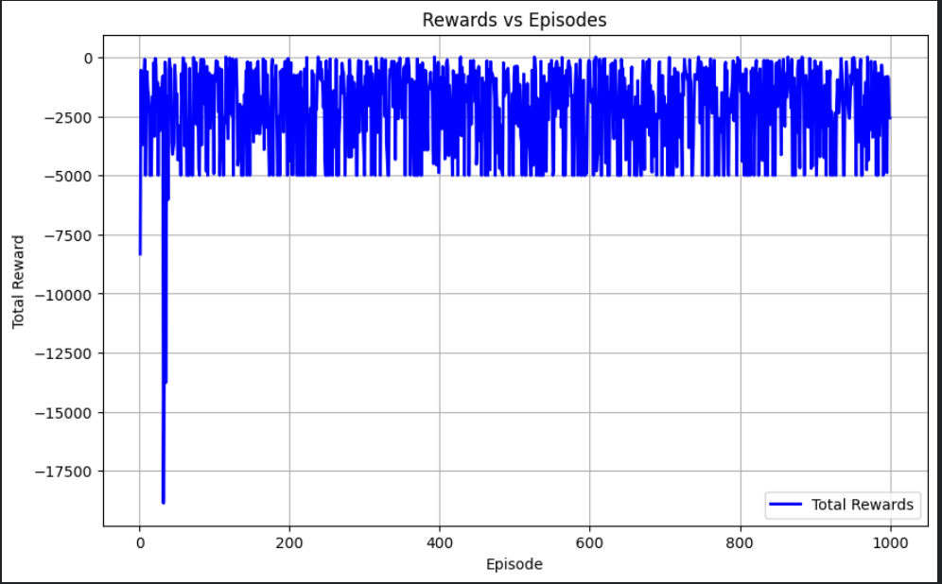

**Task 3: Advanced Evaluation and Analysis**

The trained agent failed to learn an optimal policy even after 9 hrs of training.

It learned not to bounce into any walls but it keeps oscillating near the goal instead of touching it.

The agent has a 47% success rate.